Visit Report: Kamalnagar Upazila Health Complex, Lakshmipur
Date of Visit: 01/08/22; Time: 12:30 PM.
Visitor: Dr. Md. Mostafizur Rahman, Deputy Secretary (HEU) of MoHFW,
Dr. Md. Emdadul Haque, National Consultant (HEU) of MoHFW

1. We met with the UH&FPO , RMO and other medical officers. The infra-structure of the Upazilla Health Complex is 50 bedded. From 2016 the hospital functioning as 50 bedded hospital, but indoor & OT in the new building yet not started. There are 6 posts of consultant, among them anesthesia, medicine and pediatrics are working but consultant gynae in deputation at Komlapur Railway Hospital. So, there is no facility for caesarean section.
2. X-Ray machine is nonfunctioning because of no radiographer, no USG machine, ECG machine is out of order. There is no MT (Lab) but one MT (TB) is working in pathology department.
4.There are 20 nurses and midwifes are working in the hospital.
5. We visited emergency, outdoor and indoor and the premises of the hospital. There are 3 emergency kit boxes in emergency department with essential drugs. Sterility is not maintaining properly. The emergency department should be close to the emergency medical officer’s room. Privacy of the patient should be maintained properly.
6. OPD service is well functioning. On an average 300 patients per day comes in the outdoor.
7. Indoor service is functioning but need more cleanliness. Bed occupancy rate is 110%. Toilet is not properly cleaned.
8. OT service is very poor. Unwanted items are stored in there, advised to shift the OT in OT complex of the new building.
9. Front side of the premises is clean.
8. The position in health service system (HSS score) was 168 in May-22 and 289 in June-22 among all the UHC of the country.
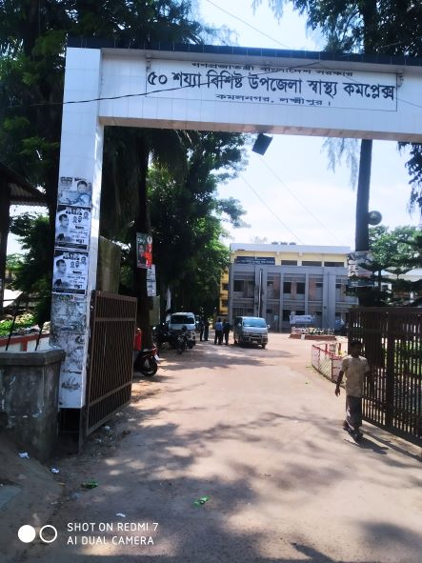

Fig-1: Front gate of Kamalnagar UHC

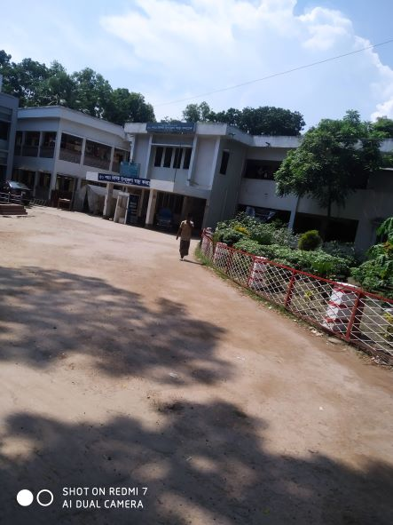
Fig-2: Clean and beautiful garden in front part of the UHC

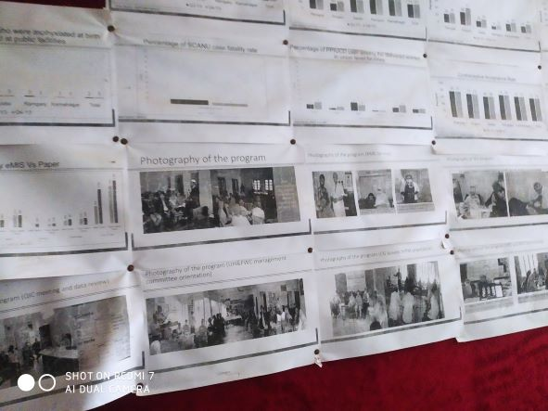
Fig-3: Display system is good but not updated

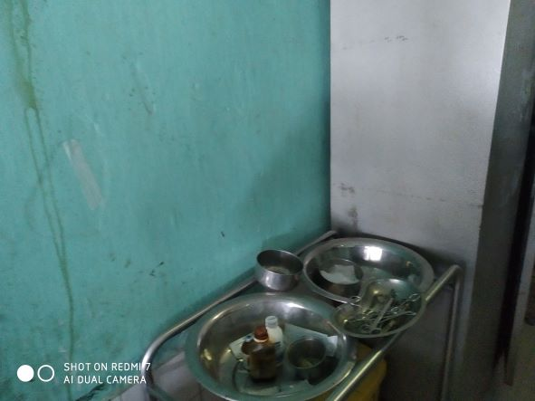
Fig-4: Instruments of emergency department

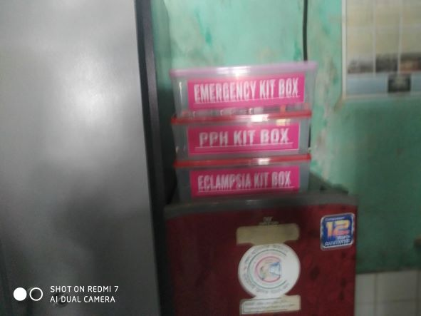
Fig-5: Emergency Kit boxes in emergency dept. (Good practice)

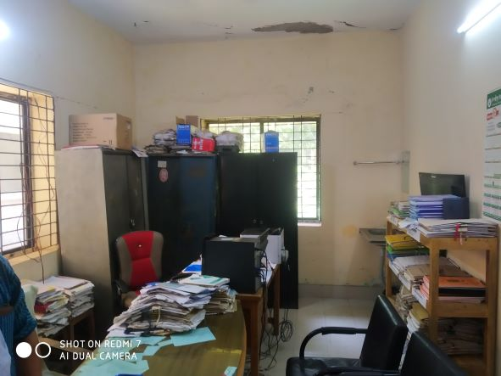
Fig-6: Office room of the UHC
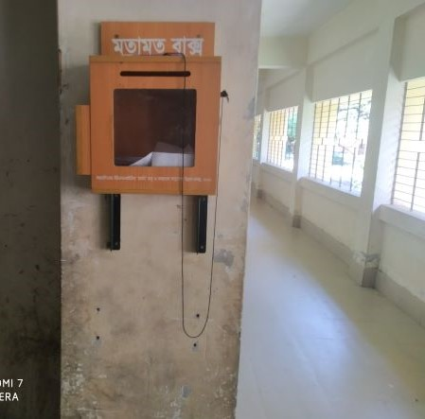
Fig-7: Suggestion box (Good practice)

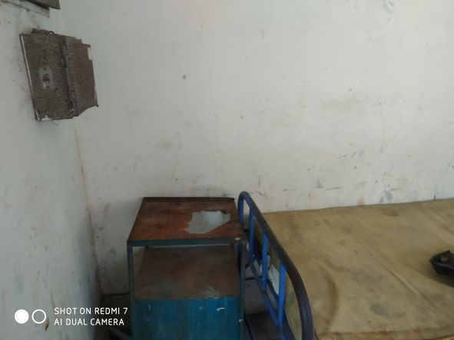
Fig-8: Unwanted items in the entry point of the indoor

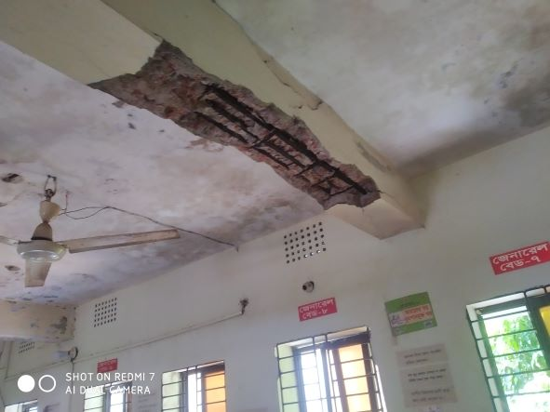
Fig-9: Risky condition of the ceiling of the indoor

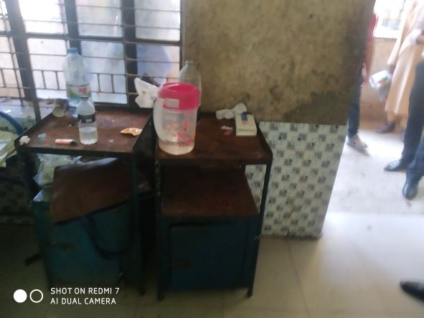
Fig-10: Unusable bedside locker in indoor

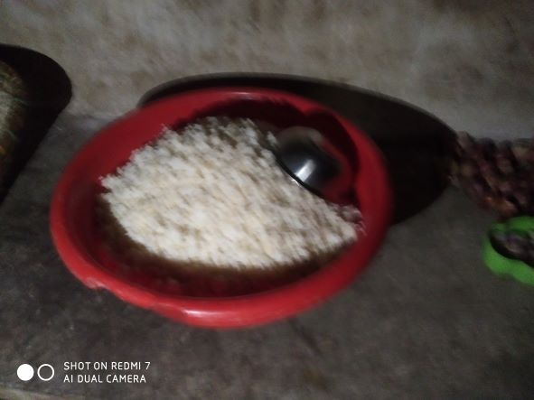
Fig-11: Supplied rice for the patients need to maintain hygienic condition

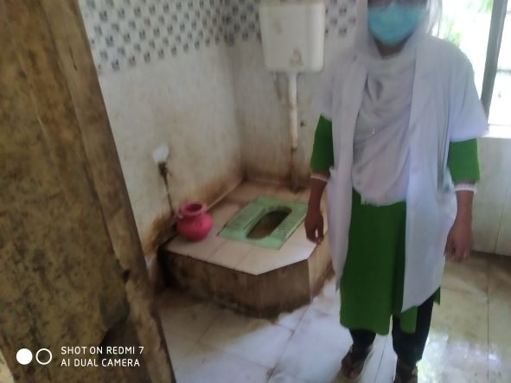
Fig-12: Unclean toilet in indoor

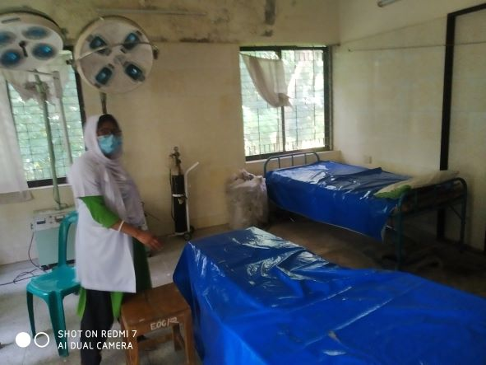
Fig-13: Patient’s bed in OT room

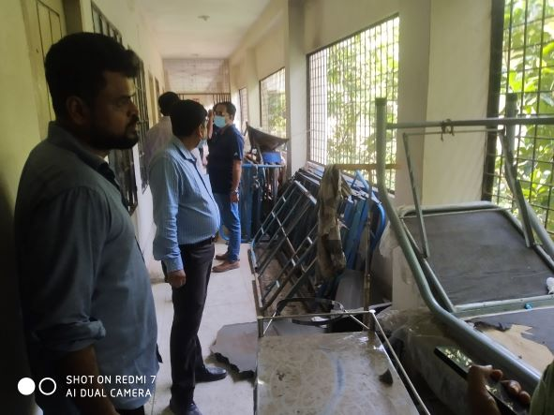
Fig-14: Unwanted items in hospital corridor

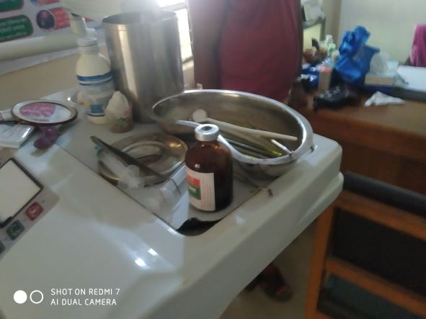
Fig-15: Uncleaned dental unit

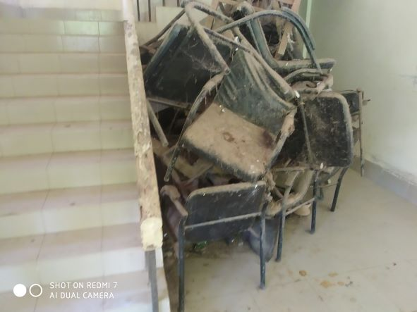
Fig-16: Unwanted items need condemnation

Health Profile of Kamalnagar UHC, Ramgoti, Laxmipur
Total population: 2,63,545
Union: 9 Sub-centre: 2 FWC: 4 Community Clinic: 22
Human Resources: 31 Bedded Hospital:
Sl. | Designation | No. of Post | Present | Vacant
 | UH&FPO | 1 | 1 | 0
 | RMO | 1 | 1 | 0
 | Junior Consultant: Medicine, Surgery, Gynae, Anestheology & Rheumatology. | 6 | 1 Medicine  1 Anaesthesia  1 Pediatrician  1 Gynae in deputation Kamlapur Railway Hospital | 2
 | Medical Officer | 8 (3+5) | 7 | 1
 | Nurses | 21 | 15 | 6
 | Mid wives | 4 | 4 | 0
 | Medical Technologist (Lab) | 2 | 2 MT (TB) | 0
 | MT EPI | 1 | 1 | 0
 | Dental Technologist | 1 | 0 | 1
 | MT (Radiology) | 1 | 0 | 1
 | SACMO | 1 | 1 | 0
 | Health Inspector (HI) | 3 | 0 | 3
 | Assist. Health Inspector | 8 | 7 | 1
 | Health Assistant | 42 | 26 | 16
 | CHCP | 22 | 22 | 0
 | Head Assistant | 1 | 0 | 1
 | Accountant | 1 | 0 | 1
 | Statistician | 1 | 0 | 1
 | MLSS | 2 | 0 | 2
 | Aya | 2 | 0 | 2
 | Cleaner | 1 | 0 | 1
 | Cook | 1 | 0 | 1
 | FWA | 1 | 0 | 1
 | Outsourcing: Cleaner, Cook, Guard, Ward boy, Aya. | 16 | 14 | 2

Status of Building Blocks of C-J Model in the Ramgoti UHC:
Sl | Criteria of C-J Model | Best | Good | Weak
 | Cycle stand close to the main gate |  |  | √
 | Health Education |  |  | √
 | Cleanliness & beautification |  | √
 | Separation of patients in out door & indoor |  | √
 | Blood doner list with 24/7 B.T facility |  | √
 | Birth- death recording |  | √
 | Reception Desk |  |  | √
 | Developed Emergency Dept. |  | √
 | 5S –KAIZEN implementation
 | Community Participation |  |  | √
 | Hospital activities Display |  |  | √
 | Corner based service |  | √
 | Cash counter for receiving Govt money |  |  | √
 | Devolped maternal health/labour word |  |  | √
 | Devolped paediatric health |  |  | √
 | Position in HSS score |  |  | √
 | Power point Presentation &Video on UHC |  |  | √
 | Knowledge about 8th Five Year plan & SDG. |  |  | √
 | Zero-Tollarance on corruption |  | √

Recommendations:
1.Part of indoor & OT should be shifted to new building as soon as possible.
2. A radiographer is needed for operating X-Ray machine. USG machine should be supplied and ECG machine needs to be replaced.
3. The location of the emergency department should be close to the emergency medical officer’s room. Sterility should be maintained .Privacy of the patient should be maintained properly.
4. Ceiling of the indoor ward should be repaired immediately. Close attention should be given on cleanliness in indoor. Indoor toilet should be cleaned properly. Unwanted items should be removed.
5. Suggestion box should be replaced to Complain and suggestion box.
6. Replication of C-J model will help in development of the quality of care.
7. Drugs and medical equipment’s are kept disorganized in the OT complex of the new building which should be organized in the store.
8. Unwanted items should be condemned as soon as possible.

The report is reviewed by-
- Md. Shahadat Hossain, PhD - National Consultant
- Dr. Md. Mustafizur Rahman -Deputy Director

